This part was at the top of the track.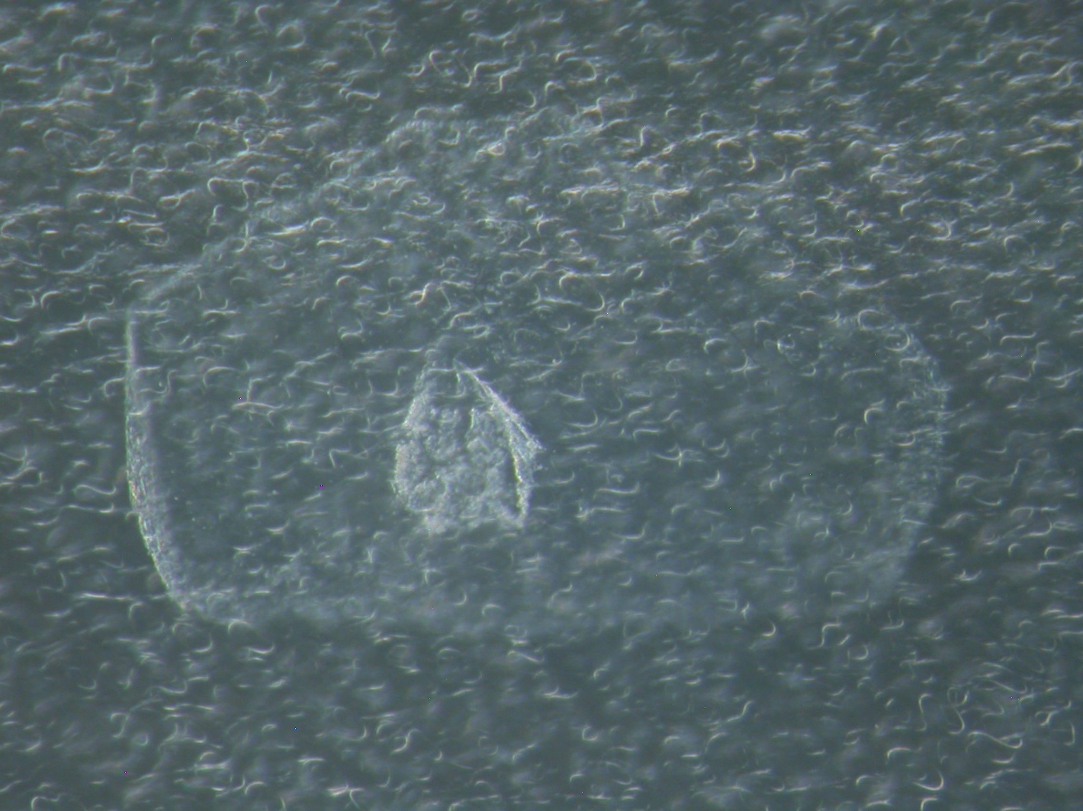There was a missing part which didn’t make it back to Earth, or at least back to Berkeley, and then the middle section contained most of the remaining track.

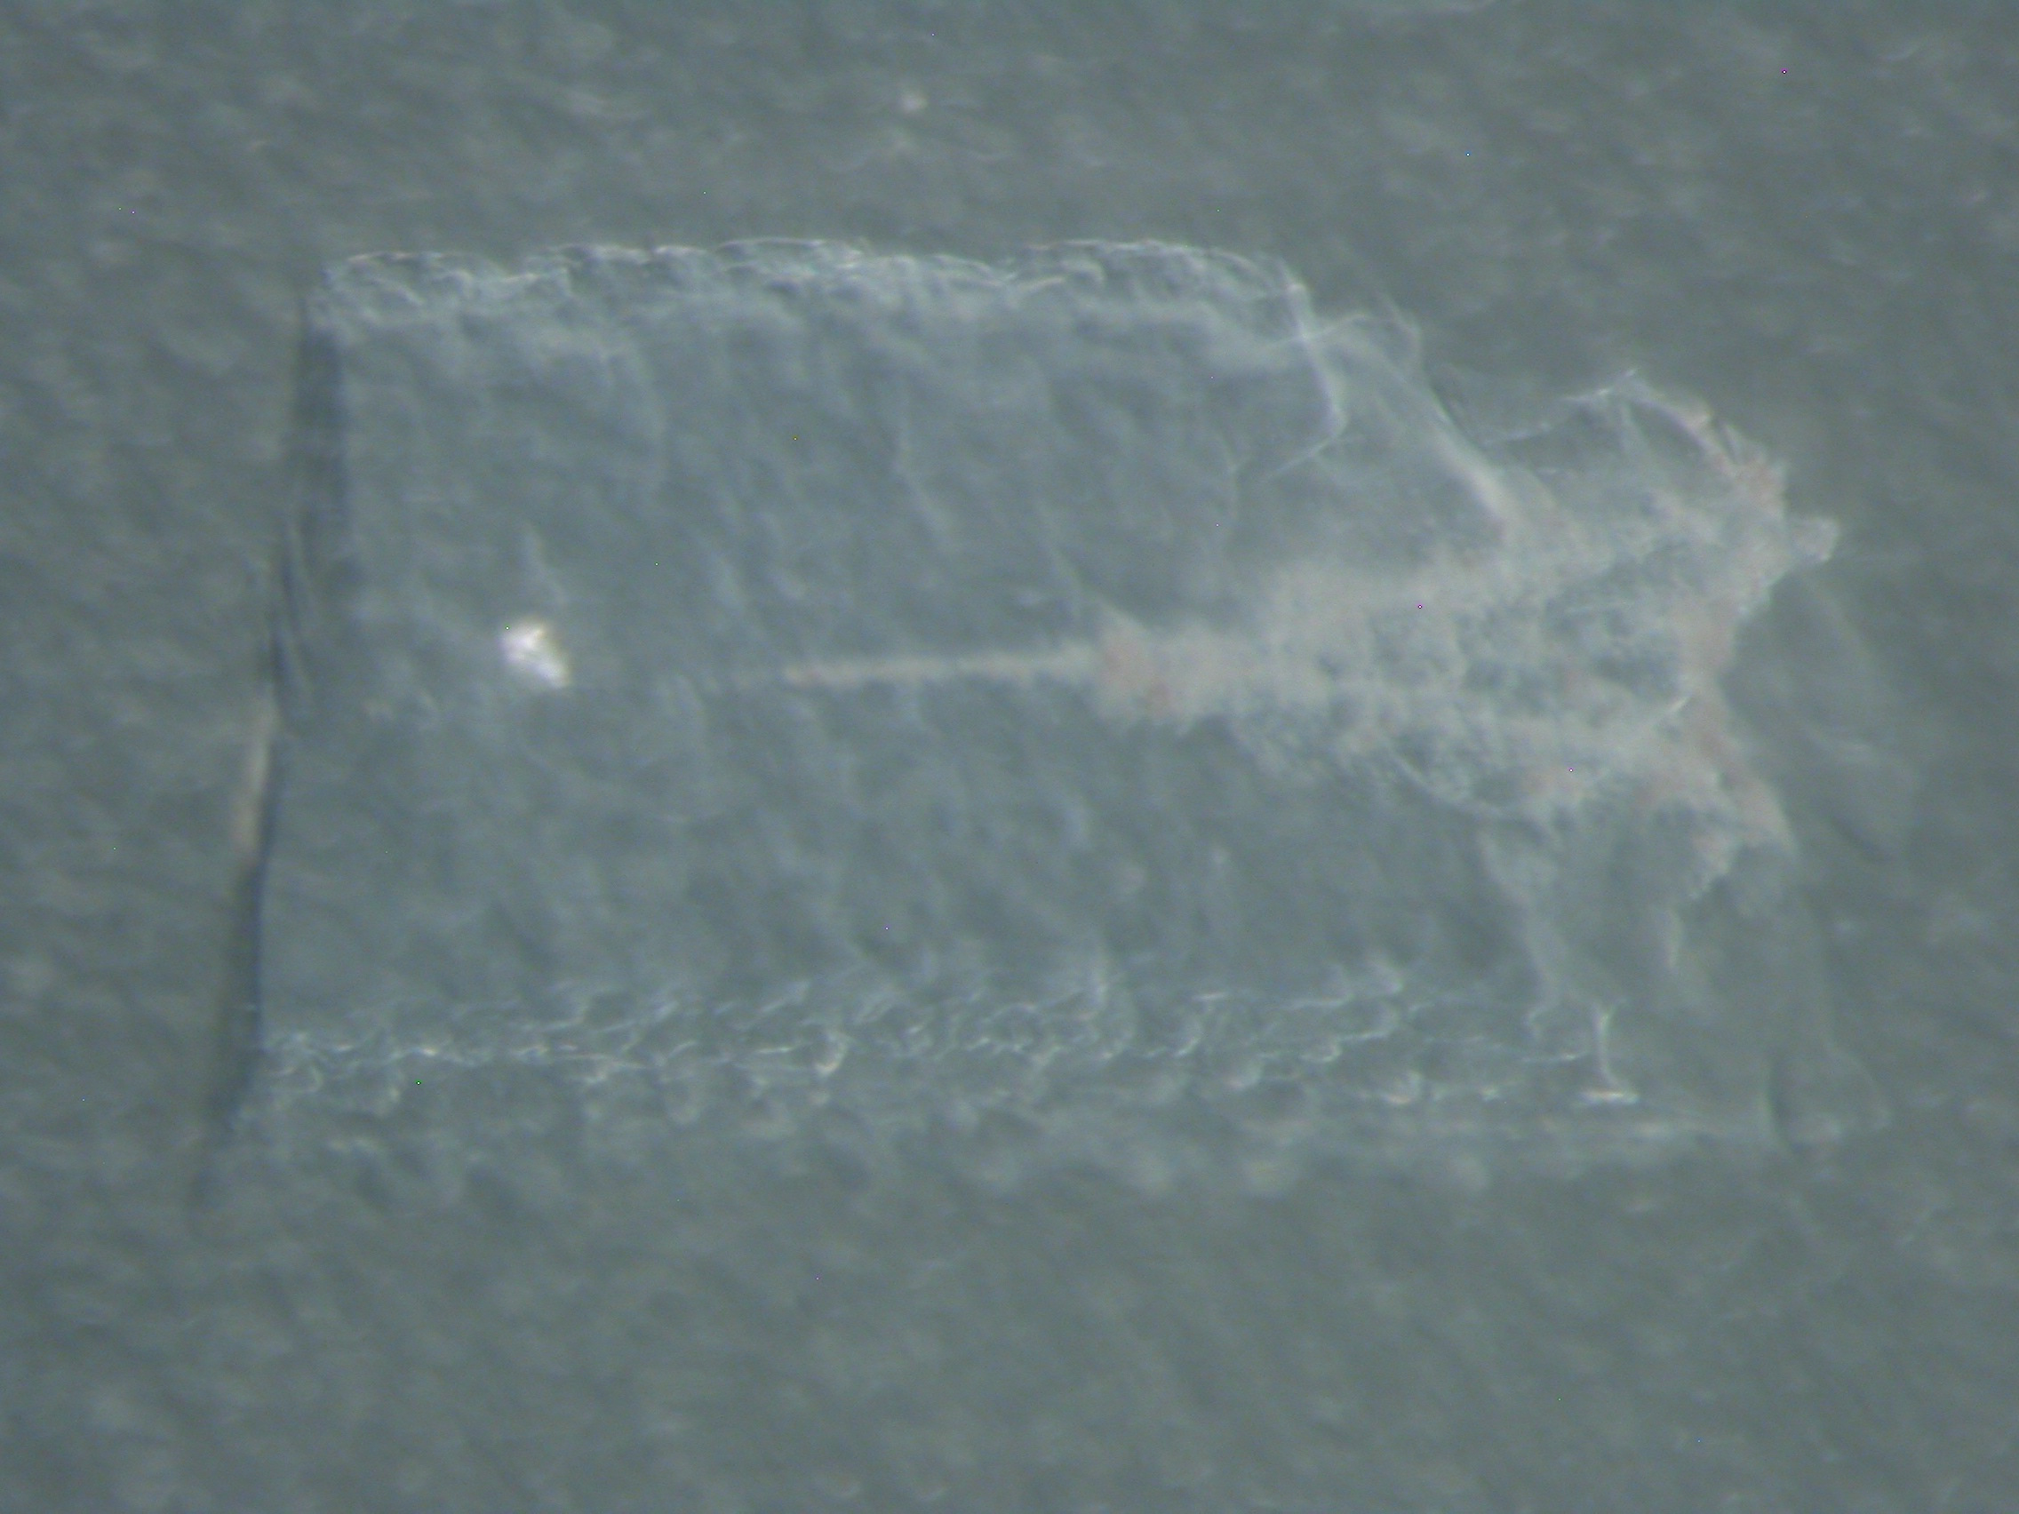Lastly, is the base of the track. The right side is the outside of the tile.



